Nama : Muhammad Nabil Afrizal Rahmadani

NRP : 5025231014

**Sistem Basis Data**

Latihan 10

Diberikan suatu database

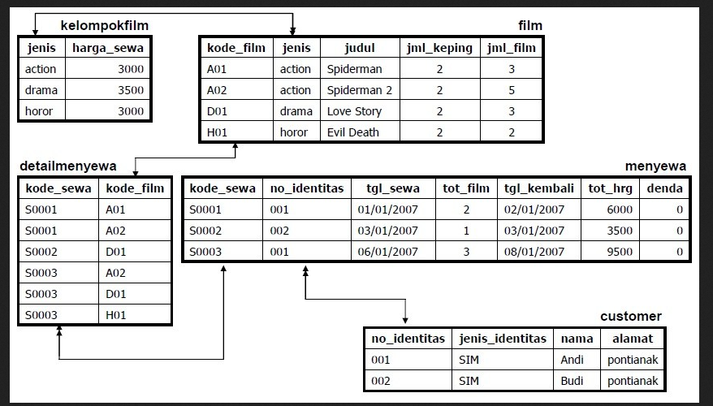

Soal 1

1. Buatlah database dengan format nama : **persewaan_NRP**. Contoh: **persewaan_12314112312**

Jawaban:

Untuk membuat database dengan format **persewaan_NRP**, dapat menggunakan query

CREATE DATABASE persewaan_5025231014;

Agar MySQL langsung menggunakan database yang kita inginkan, dapat ditambahkan query

USE persewaan_5025231014;

Final Query

Screenshot Database

1. Buatlah DDL untuk gambar database => create table dan insert table (NB: tipe data menyesuaikan)

Jawaban:

Untuk membuat **DDL** atau **Data Definition Language** sesuai dengan database diatas dapat menggunakan query sebagai berikut:

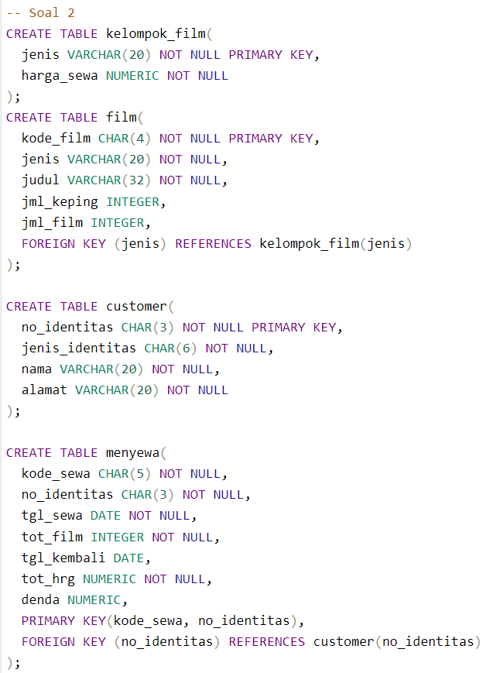

Screenshot Tabel

Isi Tabel

1. Tabel customer

1. Tabel detailmenyewa

1. Tabel film

1. Tabel kelompok_film

1. Tabel menyewa

1. Tambahkan atribut no_hp pada tabel customer dengan tipe data varchar

Before :

After :

1. Ubah nama atribut no_hp menjadi no_wa

Before :

After :

1. Hapus atribut jenis_identitas pada tabel customer

Before :

After :

1. Buat genre komedi pada tabel kelompok dengan harga sewa 5000

Before :

After :

1. Tambahkan data pada tabel film

Before :

After :

1. Lakukan update data pada bagian harga di tabel kelompok film dengan mengalikan 10 pada harga sewa.

Before :

After :

